MALAWI UNIVERSITY OF SCIENCE AND TECHNOLOGY
PHYS-111 Lecture 5 Tutorial questions
- A 330-kg piano slides 3.6 m down a 28⁰ incline as in figure 1 and is kept from accelerating by a man who is pushing back on it parallel to the incline. The effective coefficient of kinetic friction is 0.40. Calculate;
  - The force exerted by the man.
  - The work done by the man on the piano.
  - Work done by the friction force.
  - Work done by the force of gravity.
  - Net work done on the piano.
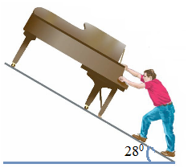
Figure 1
- A ski starts from rest and slides down a 22ᵒ incline 75 m long. If the coefficient of kinetic friction is 0.09, what is the ski’s speed at the base of the incline?
- A 3.00 kg crate slides down a ramp at a loading dock. The ramp is 1.00 m in length and inclined at an angle of 30.0⁰. The crate starts from rest at the top, experiences a constant frictional force of magnitude 5.00 N, and continues to move a short distance on the flat floor.
  - Use the work energy theorem to predict the speed of the crate when it reaches the bottom of the ramp.
  - Use the law of conservation of mechanical energy to predict the speed of the crate when it reaches the bottom of the ramp
- The electric motor of a model train accelerates the train from rest to 0.620 m/s in 21 ms, the total mass of the train is 875 g. Find the average power delivered to the train during its acceleration.
- A novice skier, staring from rest, slides down a 35ᵒ incline whose vertical height is 185 m. How fast is she going when she reaches the bottom? The coefficient of kinetic friction between the plane and the skier is 0.12.
- If the coefficient of kinetic friction for figure 2 is 0.22, determine:
  - The net work done on the box, the box moves 2 m.
  - Work done by the normal force as it moves 2 m downhill.
  - The work done by friction as it moves 2 m downhill.
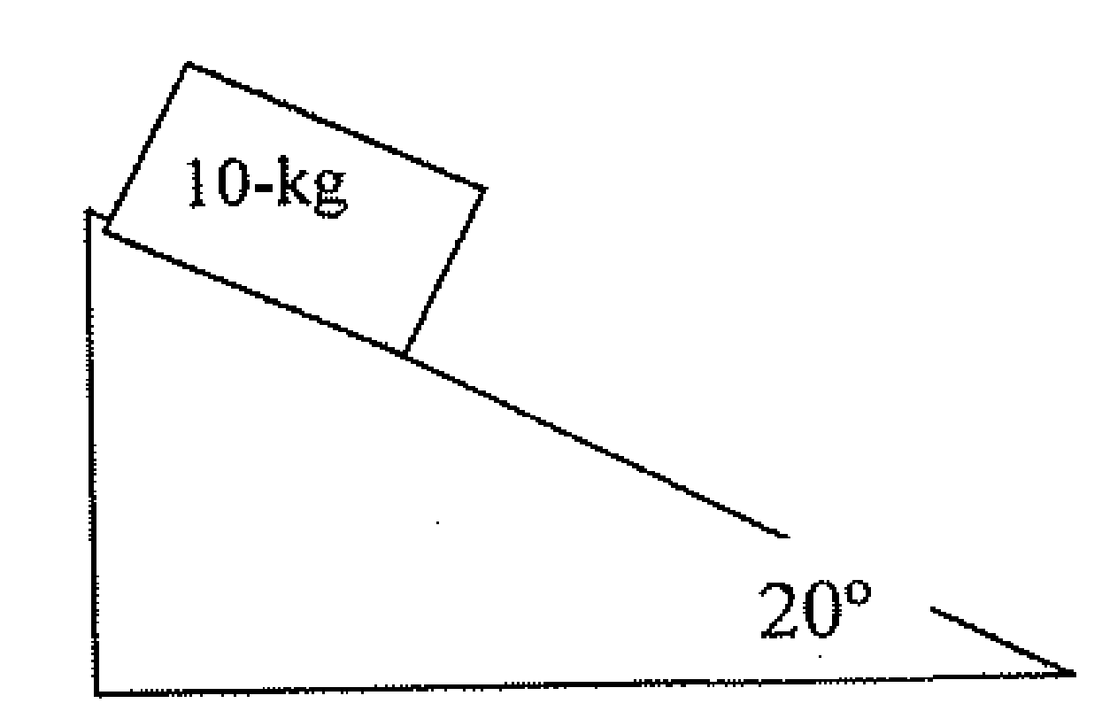
Figure 2
- Two objects are connected by a light string passing over a light frictionless pulley as shown in Figure 3. The object of mass 5.00 kg is released from rest. Using the principle of conservation of energy.
  - Determine the speed of the 3.00-kg object just as the 5.00-kg object hits the ground.
  - Find the maximum height to which the 3.00-kg object rises.
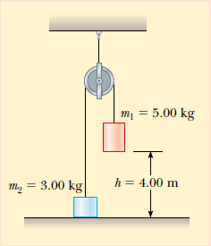
Figure 3

